Impact of Macroeconomic Variables on UK CRE Yields
An Econometric Analysis

- Introduction, Summary & Data

Throughout this report we examine the impact of Bank of England (BoE) base rate, CPI inflation and GDP growth on London and regional office yields by performing two OLS regressions. We note the differences between these two areas and periods for when yields move sharply relative to what the macroeconomic variables predict and discuss the potential causes for this.

It is important to understand the macroeconomy’s impact on yields because this allows us to use our understanding of the future macroeconomic environment to make decisions that will drive the greatest returns.

The data used to investigate the impact of BoE rate, CPI and GDP growth spans from 2016 to 2026 in bi-annual intervals and the data is sourced from the Bank of England database, Savills’ Market in Minutes and the ONS.

2.0 Methodology and Model Specification

We created two independent models for London and Regional yield responses to macroeconomic variables so we could capture their differing relationship caused by a divergence between the conditions of London and regional markets. The models are outlined below:

$Y_{L}= β_{0}+ β_{1}\left(BoErate\right)+ β_{2}\left(CPI\right)+ β_{3}(GDPGrowth)+ϵ_{i}$
$Y_{R}= α_{0}+α_{1}\left(BoErate\right)+α_{2}\left(CPI\right)+ α_{3}\left(GDPGrowth\right)+ϵ_{i}$

Linear regression was selected because the limited ranges of the predictor variables meant that even if a non-linear relationship may develop for larger values, a linear approximation would be sufficient (as reflected by the residuals plot in the appendix). Furthermore, linear relationships are much more interpretable and non-linear models risk overfitting given then small sample size.

BoE rate was included because it represents the opportunity cost of investing in CRE. An investor always has the risk-free option of UK gilts; consequently, an uptick in BoE rate will reduce the risk adjusted rate of return provided by property yields. Hence, to offset this change in preferences, asset prices adjust downward, forcing property yields up to maintain demand. Furthermore, since real estate is a highly leveraged asset class, the corresponding rise in debt servicing costs means buyers pay less for property – pushing yields up.

We also included GDP growth as a predictor variable because if businesses are expanding and consumers have more income, we can expect property demand to be higher which leads to rental growth. Because investors are willing to pay a premium for future growth, property yields fall. Finally, CPI is included as a predictor because it has a dual impact. In the short term, higher yields are demanded to counteract erosion of purchasing power. However, if inflation leads to rising supply costs, property prices will increase leading to yields being compressed.

3.0 Diagnostic Checks

To ensure regression analysis is valid, the assumptions for OLS must be checked. Firstly, to check for multicollinearity we created a correlation matrix (Appendix, Figure 1) to visualise the relationships between the predictor variables. A value >0.80 would have suggested a multicollinearity issue. To formally check for multicollinearity, we carried out the variance inflation factor test. Since all values obtained were below 5, this suggests there is no multicollinearity problem.

BoE_Rate | CPI | GDP_Growth
1.343598 | 1.342791 | 1.003257
Note: Values indicate Variance Inflation Factor (VIF).

To check for homoscedasticity a scale-location plot was set up (Appendix, Figure 1) and a Breusch Pagan test was carried out for both London and Regional yields. The respective test statistics and p-values are as follows. BP = 4.738, $p$ = 0.192, BP = 3.5415, $p$ = 0.3154. From these results, it is clear that the homoscedasticity assumption holds.

Following that, to check for linearity and normal distribution of $ϵ_{i}$ , we created a residuals plot and a QQ plot for each respective assumption (Appendix, Figure 1, Figure 2). Furthermore, to see if there were any influential observations that could distort our results, we fitted a Residuals-Leverage plot. For regional yields, no points lay outside Cook’s distance. However, for London yields there were 2 points that lay outside of Cook’s distance: H1 2020 (4.50) and H2 2020 (0.74) where GDP growth swung from -22.1% to +18.6% within a half-year. These data points were influential but accurate; hence, they have been left in as part of the regression analysis.

Finally, the time series nature of the data utilised means that autocorrelation is a risk. Hence, we addressed this using HAC standard errors to obtain a more accurate value for our standard errors.

4.0 Empirical Results

UK CRE Yields Relationship with Macroeconomic Indicators
Variable | London Office Yield (%) (1) | Regional Office Yield (%) (2)
Bank of England Base Rate (%) | 0.138*** | 0.415***
 | (0.027) | (0.056)
CPI Inflation (%) | -0.052** | -0.187***
 | (0.021) | (0.027)
GDP Growth (%) | 0.005 | 0.020***
 | (0.012) | (0.001)
Constant | 3.516*** | 5.293***
 | (0.170) | (0.151)
Observations | 21 | 21
R² | 0.462 | 0.786
Adjusted R² | 0.367 | 0.748
Note: *p<0.1; **p<0.05; ***p<0.01

For London office yield the coefficient for the BoE base rate is 0.138 at the 1% level whereas for regional office yields it was 0.415 at the 1% level. The respective standard errors of the coefficients were 0.027 and 0.056.

For London office yield the coefficient for CPI inflation is -0.052 at the 5% level whereas for regional office yields it was -0.187 at the 1% level. The respective standard errors of the coefficients were 0.021 and 0.027.

For London office yield the coefficient for GDP growth is 0.005 which is not statistically significant whereas for regional office yields it was 0.020 at the 1% level. The respective standard errors of the coefficients were 0.012 and 0.001.

For London office yield the constant is 3.516 at the 1% level whereas for regional office yields it was 5.293 at the 1% level. The respective standard errors of the constants were 0.170 and 0.151.

The London model has an R² of 0.462 (Adjusted R² = 0.367) and the regional model has an R² of 0.786 (Adjusted R² = 0.748) which means that the three predictor variables account for 46.2% and 78.6% of the variation in yields across the 21 half-years.

5.0 Actual vs Fitted Yields

The graphs below illustrate the expected yields for both London and Regional offices based on the macroeconomic indicators’ values at corresponding times between 2016 and 2026.

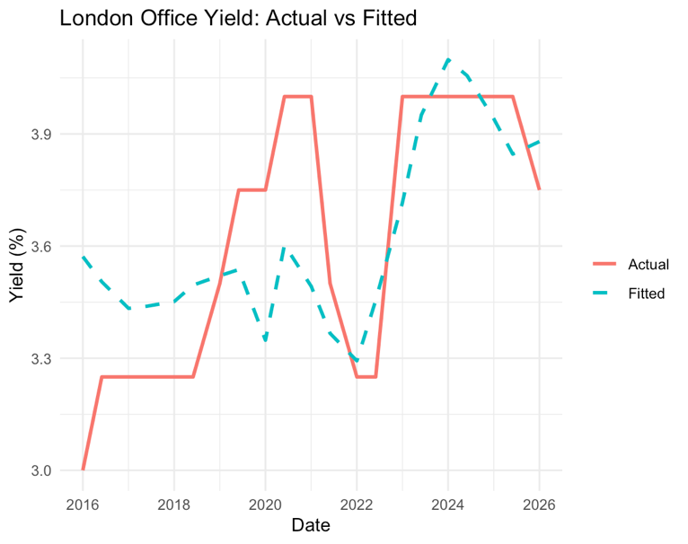 | 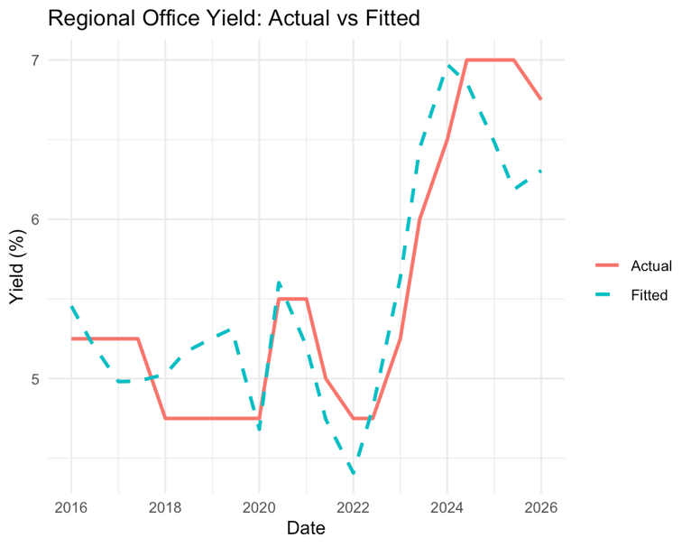

For both models, the actual and fitted values track reasonably accurately, revealing that the regression model has predictive utility. However, it is clear that the regional office yield values are a closer fit to the expected values than the London office yields as shown by the dashed line. The period in which the fitted yields for London offices are least accurate is between 2019 and 2021, where the predicted values underestimated the sharp rise in yields.

6.0 Key Takeaways

The models for expected yields are more accurate for regional offices than London because there are fewer contributing factors outside of BoE rate, CPI inflation and GDP Growth. Since London is a global market, key drivers also include currency fluctuations, FDI and US treasury returns. Furthermore, London offices’ value has a greater tie to its ability to be a reliable vehicle to hold wealth and appreciate over time due to supply constraints.

These factors also contribute to the divergence between London’s R² of 0.462 which is 0.326 units lower than the regional model’s R² of 0.786. The gap between the R² and adjusted R² for both regions is because the second statistic prevents overfitting data points when we have a small sample. This is prevalent in this situation since we have 3 predictors and 21 observations; the low severely restricts our degrees of freedom, making the adjusted R² a more reliable measure.

The London office yield coefficient for the BoE base rate is less than the regional office yield coefficient because investors in regional offices may be more concerned with generating a return than maintaining their wealth. For example, if bank rates were to increase over a period investors would choose to reallocate capital away from regional offices for a greater risk adjusted rate return. To offset these changes in preferences, regional office yields increase to prevent an excess of supply.

Both the London office yields and the regional office yields’ coefficient for the CPI inflation rate is negative. With CPI inflation rate having a greater influence over regional office yields. Though this is expected, due to a greater number of confounding variables in the London market. The reason for this negative coefficient may be that investors rotate capital into real assets to avoid the risk of persistent inflation eroding the purchasing power of their cash holdings. As a result of this increased demand for real assets, including property, prices rise, hence compressing yields.

The coefficient for GDP growth is positive for both London and regional yields, though only marginally with respective values at 0.005 and 0.020. The propensity for coefficients to trace around zero contradicts our hypothesis in which we expected a negative relationship. The COVID period produced extreme GDP swings, combined with a sample size of 21, this would have pulled the relationship in opposite directions leading to an overall coefficient close to zero. Additionally, it is worth noting that the regional coefficient was significant at the 1% level and the London coefficient is not significant. This is likely due to London having more confounding variables and consequently inflating the standard error.

In 2020, yields rose as a result of the global pandemic. The London yields rose from 3.75% to 4%, while the regional yields rose from 4% to 5.5%. These yield changes are a result of the increased economic uncertainty caused by the pandemic, people did not know when the lockdown would end and people were unsure to the scale of the impact working at home would have on a requirement for offices long term.

Between 2022 and 2023 yields rose from 4.75% to 7% for regional offices and 3.25% to 4% for London offices. This occurred because of the BoE hiking rates from ~0.1% to 5% in order to combat rising inflation which peaked at 11%. Further uncertainty was brought about by the mini-budget issued by Liz Truss which caused a spike in gilt yields which consequently caused CRE yields to rise.

7.0 Limitations

We have a sample size of twenty-one which includes a time period of significant economic crises. While we are provided with a satisfactory range of values, a lack of a stable environment prevents us from studying the isolated impact of CPI inflation, GDP growth and BoE rate on CRE yields. This is a result of the relationship between these predictors being distorted during crises. Furthermore, there are a number of influential predictors not included in our model. For example, one might consider vacancy rates, regulatory pressure and the supply pipeline all of which are independent of the predictors employed.

Because of the time series nature of the data, we did not formally test for autocorrelation (e.g. a Breusch-Godfrey test or Durbin-Watson statistic) and assumed its existence. We applied HAC standard errors to correct for this risk.

Another limitation is the inclusion of H1 and H2 2020 in the London model of which the former had a Cook’s distance of 4.50. As a result, the coefficients calculated are predominantly a reflection of this economic shock rather than a relationship we would expect to see in a usual economic cycle. However, we chose to keep this data because it contributed to a complete and representative analysis of 2016-2026.

An alternative approach to finding the relationship between these predictor variables and CRE yields would have been to pool both London and regional into one linear relationship. This would have provided 42 observations and allowed for a direct comparison between London and regional’s reaction to each predictor variable, providing its own standard error and significance level within the interaction term. However, the method chosen is more interpretable and provides greater clarity when analysing the results.

Overall, our results show a directional association between our independent variables and CRE yields during an atypical decade rather than a precise estimate of a long-term stable relationship.

Appendix

Figure 1: Correlation Matrix of CRE Yields and Macroeconomic Indicators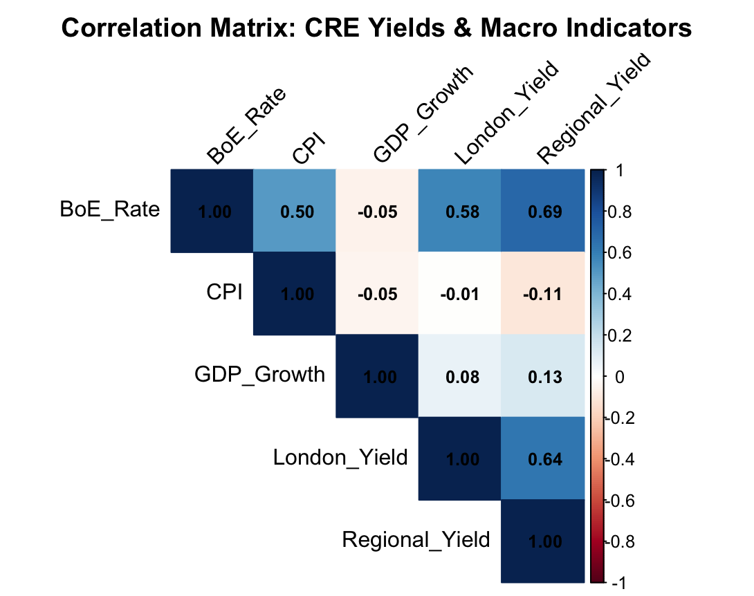

Figure 2: OLS Diagnostic Plots for Regional Office Yield Model
Includes: (a) Residuals vs Fitted values to evaluate linearity and homoskedasticity; (b) Normal Q-Q plot to assess residual normality; (c) Scale-Location plot for homoskedasticity check; and (d) Residuals vs Leverage plot to identify influential outliers or high-leverage data points.

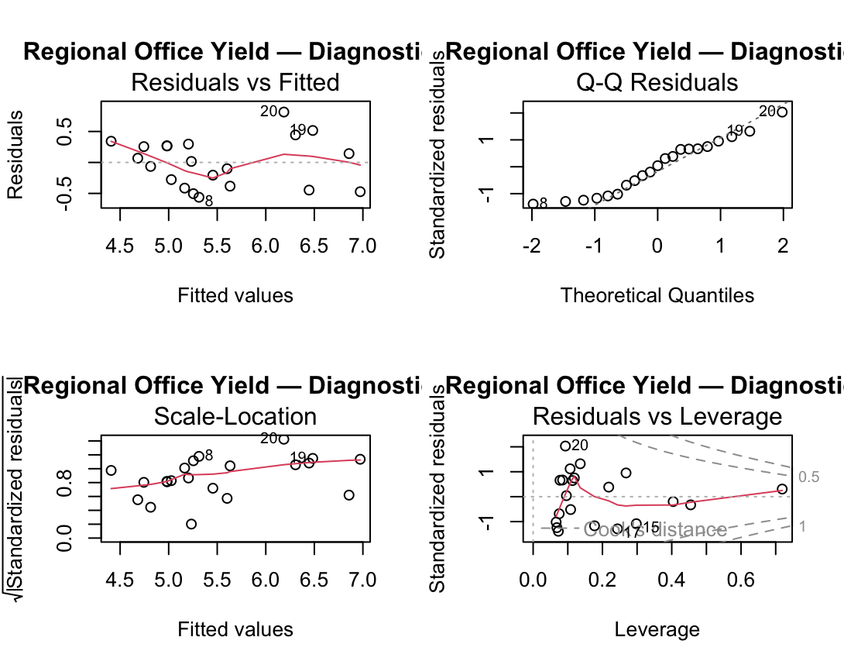

Figure 3: OLS Diagnostic Plots for London Office Yield Model
Includes: (a) Residuals vs Fitted values to evaluate linearity and homoskedasticity; (b) Normal Q-Q plot to assess residual normality; (c) Scale-Location plot for homoskedasticity check; and (d) Residuals vs Leverage plot to identify influential outliers or high-leverage data points.
